Title-1: Deep Learning Based Traffic Speed Prediction Using Long Short Term Memory for Improving Accuracy Compared with K-Nearest Neighbors Algorithm

Code:

import pandas as pd

from sklearn.model_selection import train_test_split

from sklearn.neighbors import KNeighborsRegressor

from sklearn.metrics import mean_squared_error

from sklearn.preprocessing import MinMaxScaler

from tensorflow.keras.models import Sequential

from tensorflow.keras.layers import LSTM, Dense

import numpy as np

import matplotlib.pyplot as plt

# Load your dataset

file_path = 'your_dataset.csv' # Replace with the actual path to your dataset

df = pd.read_csv(file_path)

# Assuming your dataset has columns like 'Year', 'Month', 'Speed', 'CarCount', 'BikeCount', 'BusCount', 'TruckCount', 'Total'

# Adjust columns accordingly

features = df[['Year', 'Month', 'CarCount', 'BikeCount', 'BusCount', 'TruckCount', 'Total']]

target = df['Speed']

# Split the data into training and testing sets

X_train, X_test, y_train, y_test = train_test_split(features, target, test_size=0.2, random_state=42)

# K-Nearest Neighbors

knn_model = KNeighborsRegressor(n_neighbors=5) # You can adjust the number of neighbors

knn_model.fit(X_train, y_train)

knn_predictions = knn_model.predict(X_test)

knn_rmse = np.sqrt(mean_squared_error(y_test, knn_predictions))

knn_accuracy = 1 - knn_rmse / np.mean(y_test)

print(f"KNN Accuracy: {knn_accuracy * 100:.2f}%")

# Long Short-Term Memory (LSTM)

# Normalize the data using MinMaxScaler

scaler = MinMaxScaler()

scaled_features = scaler.fit_transform(features)

# Reshape the data for LSTM (assuming 6 frames as input)

X_lstm = np.array([scaled_features[i-6:i] for i in range(6, len(scaled_features))])

y_lstm = np.array(target[6:])

# Split the LSTM data into training and testing sets

X_lstm_train, X_lstm_test, y_lstm_train, y_lstm_test = train_test_split(X_lstm, y_lstm, test_size=0.2, random_state=42)

# Build the LSTM model

lstm_model = Sequential()

lstm_model.add(LSTM(50, input_shape=(X_lstm_train.shape[1], X_lstm_train.shape[2])))

lstm_model.add(Dense(1))

lstm_model.compile(optimizer='adam', loss='mse')

# Train the LSTM model

lstm_model.fit(X_lstm_train, y_lstm_train, epochs=10, batch_size=32, verbose=1)

# Evaluate the LSTM model

lstm_predictions = lstm_model.predict(X_lstm_test)

lstm_rmse = np.sqrt(mean_squared_error(y_lstm_test, lstm_predictions))

lstm_accuracy = 1 - lstm_rmse / np.mean(y_lstm_test)

print(f"LSTM Accuracy: {lstm_accuracy * 100:.2f}%")

# Bar graph comparing accuracies

models = ['KNN', 'LSTM']

accuracies = [knn_accuracy, lstm_accuracy]

plt.bar(models, accuracies, color=['blue', 'orange'])

plt.ylabel('Accuracy')

plt.title('Comparison of KNN and LSTM Accuracies')

plt.ylim(0, 1) # Set the y-axis limit to 0-1 for percentage

plt.show()

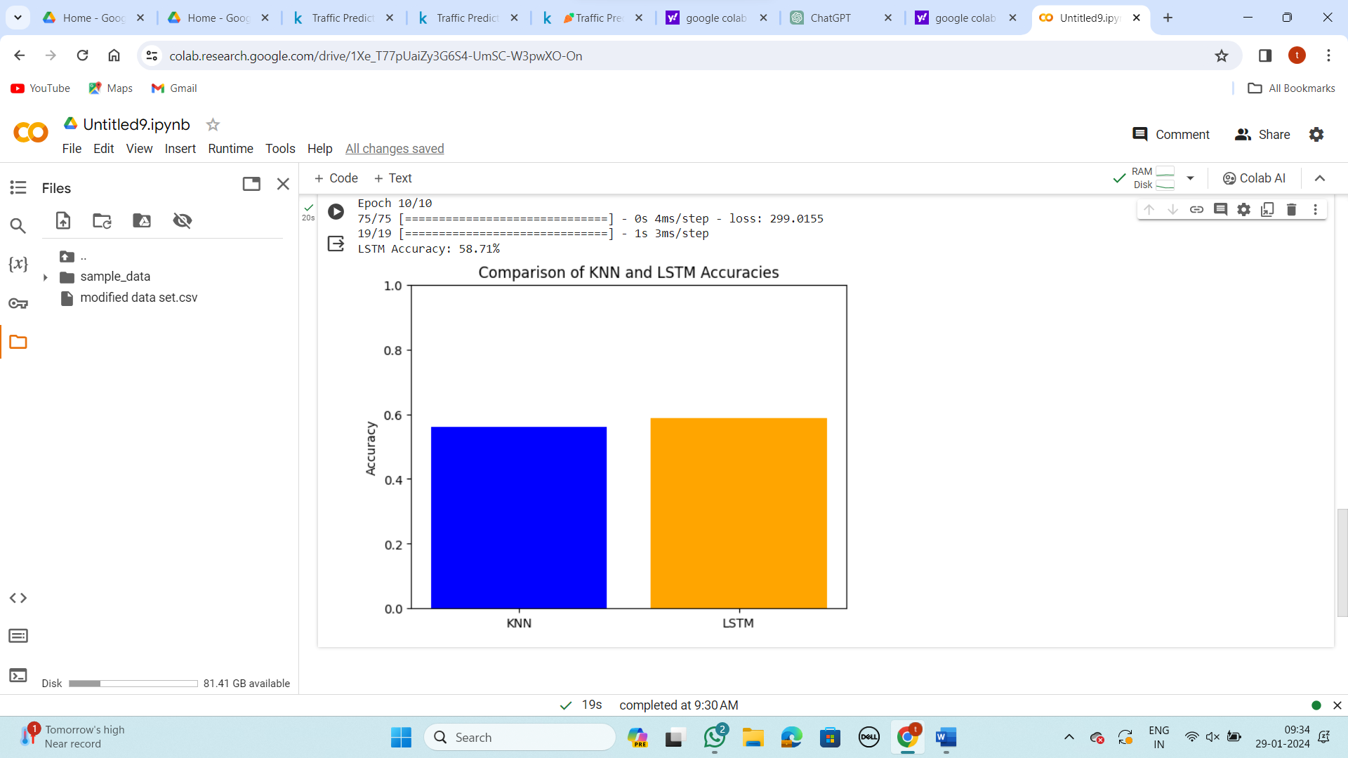

Title-2: Deep Learning Based Traffic Speed Prediction Using Long Short Term Memory for Improving Accuracy Compared with Support Vector Regression Algorithm

Code:

import pandas as pd

import numpy as np

from sklearn.model_selection import train_test_split

from sklearn.svm import SVR

from sklearn.metrics import mean_squared_error

from sklearn.preprocessing import MinMaxScaler

from tensorflow.keras.models import Sequential

from tensorflow.keras.layers import LSTM, Dense

import matplotlib.pyplot as plt

# Load your dataset

file_path = 'your_dataset.csv' # Replace with the actual path to your dataset

df = pd.read_csv(file_path)

# Select relevant features

features = df[['Year', 'Month', 'CarCount', 'BikeCount', 'BusCount', 'TruckCount', 'Total']]

target = df['Speed']

# Normalize the data

scaler = MinMaxScaler()

scaled_features = scaler.fit_transform(features)

# Reshape the data for LSTM (assuming 6 frames as input)

X_lstm = np.array([scaled_features[i-6:i] for i in range(6, len(scaled_features))])

y_lstm = np.array(target[6:])

# Split the data into training and testing sets

X_train, X_test, y_train, y_test = train_test_split(X_lstm, y_lstm, test_size=0.2, random_state=42)

# Support Vector Regressor (SVR)

svr_model = SVR()

svr_model.fit(X_train.reshape(X_train.shape[0], -1), y_train)

svr_predictions = svr_model.predict(X_test.reshape(X_test.shape[0], -1))

svr_rmse = np.sqrt(mean_squared_error(y_test, svr_predictions))

svr_accuracy = 1 - svr_rmse / np.mean(y_test)

# LSTM

lstm_model = Sequential()

lstm_model.add(LSTM(50, input_shape=(X_train.shape[1], X_train.shape[2])))

lstm_model.add(Dense(1))

lstm_model.compile(optimizer='adam', loss='mse')

lstm_model.fit(X_train, y_train, epochs=10, batch_size=32, verbose=1)

lstm_predictions = lstm_model.predict(X_test)

lstm_rmse = np.sqrt(mean_squared_error(y_test, lstm_predictions))

lstm_accuracy = 1 - lstm_rmse / np.mean(y_test)

# Comparison and Visualization

models = ['SVR', 'LSTM']

accuracies = [svr_accuracy, lstm_accuracy]

plt.bar(models, accuracies, color=['blue', 'green'])

plt.ylabel('Accuracy')

plt.title('Comparison of SVR and LSTM Accuracy')

plt.ylim(0, 1) # Assuming accuracy is between 0 and 1

plt.show()

print(f"SVR Accuracy: {svr_accuracy * 100:.2f}%")

print(f"LSTM Accuracy: {lstm_accuracy * 100:.2f}%")

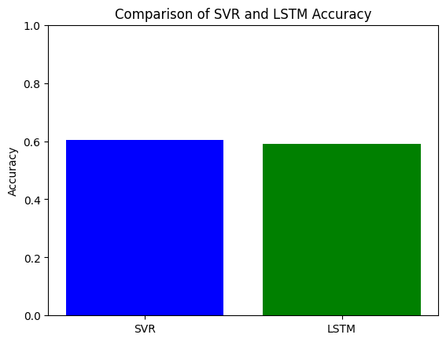

Title-3: Deep Learning Based Traffic Speed Prediction Using Long Short Term Memory for Improving Accuracy Compared with Decision Tree Algorithm

Code:

import pandas as pd

from sklearn.model_selection import train_test_split

from sklearn.tree import DecisionTreeRegressor

from sklearn.metrics import mean_squared_error

from sklearn.preprocessing import MinMaxScaler

from tensorflow.keras.models import Sequential

from tensorflow.keras.layers import LSTM, Dense

import numpy as np

import matplotlib.pyplot as plt

# Load your dataset

file_path = 'your_dataset.csv' # Replace with the actual path to your dataset

df = pd.read_csv(file_path)

# Assuming your dataset has columns like 'Year', 'Month', 'Speed', 'CarCount', 'BikeCount', 'BusCount', 'TruckCount', 'Total'

# Adjust columns accordingly

features = df[['Year', 'Month', 'CarCount', 'BikeCount', 'BusCount', 'TruckCount', 'Total']]

target = df['Speed']

# Split the data into training and testing sets

X_train, X_test, y_train, y_test = train_test_split(features, target, test_size=0.2, random_state=42)

# Decision Tree

decision_tree_model = DecisionTreeRegressor(random_state=42)

decision_tree_model.fit(X_train, y_train)

decision_tree_predictions = decision_tree_model.predict(X_test)

decision_tree_rmse = np.sqrt(mean_squared_error(y_test, decision_tree_predictions))

decision_tree_accuracy = 1 - decision_tree_rmse / np.mean(y_test)

# LSTM

# Normalize the data using MinMaxScaler

scaler = MinMaxScaler()

scaled_features = scaler.fit_transform(features)

# Reshape the data for LSTM (assuming 6 frames as input)

X_lstm = np.array([scaled_features[i-6:i] for i in range(6, len(scaled_features))])

y_lstm = np.array(target[6:])

# Split the LSTM data into training and testing sets

X_lstm_train, X_lstm_test, y_lstm_train, y_lstm_test = train_test_split(X_lstm, y_lstm, test_size=0.2, random_state=42)

# Build the LSTM model

lstm_model = Sequential()

lstm_model.add(LSTM(50, input_shape=(X_lstm_train.shape[1], X_lstm_train.shape[2])))

lstm_model.add(Dense(1))

lstm_model.compile(optimizer='adam', loss='mse')

# Train the LSTM model

lstm_model.fit(X_lstm_train, y_lstm_train, epochs=10, batch_size=32, verbose=1)

# Evaluate the LSTM model

lstm_predictions = lstm_model.predict(X_lstm_test)

lstm_rmse = np.sqrt(mean_squared_error(y_lstm_test, lstm_predictions))

lstm_accuracy = 1 - lstm_rmse / np.mean(y_lstm_test)

# Display accuracies

print(f"Decision Tree Accuracy: {decision_tree_accuracy}")

print(f"LSTM Accuracy: {lstm_accuracy}")

# Plotting the results

labels = ['Decision Tree', 'LSTM']

accuracies = [decision_tree_accuracy * 100, lstm_accuracy * 100]

plt.bar(labels, accuracies, color=['blue', 'orange'])

plt.ylabel('Accuracy (%)')

plt.title('Traffic Speed Prediction Accuracy Comparison')

plt.ylim(0, 100)

plt.show()

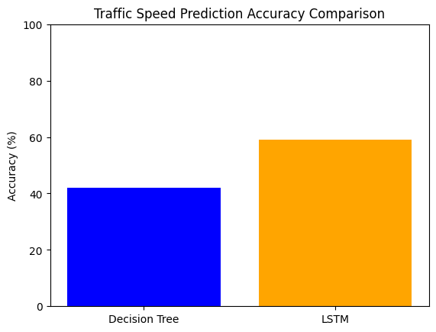

Title-4: Deep Learning Based Traffic Speed Prediction Using Long Short Term Memory for Improving Accuracy Compared with Linear Regression Algorithm

code:

import pandas as pd

from sklearn.model_selection import train_test_split

from sklearn.linear_model import LinearRegression

from sklearn.metrics import mean_squared_error

from sklearn.preprocessing import MinMaxScaler

from tensorflow.keras.models import Sequential

from tensorflow.keras.layers import LSTM, Dense

import numpy as np

import matplotlib.pyplot as plt

# Load your dataset

file_path = 'your_dataset.csv' # Replace with the actual path to your dataset

df = pd.read_csv(file_path)

# Extract relevant features

features = df[['Year', 'Month', 'CarCount', 'BikeCount', 'BusCount', 'TruckCount', 'Total']]

target = df['Speed']

# Split the data into training and testing sets

X_train, X_test, y_train, y_test = train_test_split(features, target, test_size=0.2, random_state=42)

# Linear Regression

lr_model = LinearRegression()

lr_model.fit(X_train, y_train)

lr_predictions = lr_model.predict(X_test)

lr_rmse = np.sqrt(mean_squared_error(y_test, lr_predictions))

lr_accuracy = 1 - lr_rmse / np.mean(y_test)

print(f"Linear Regression Accuracy: {lr_accuracy}")

# Long Short-Term Memory (LSTM)

# Normalize the data using MinMaxScaler

scaler = MinMaxScaler()

scaled_features = scaler.fit_transform(features)

# Reshape the data for LSTM (assuming 6 frames as input)

X_lstm = np.array([scaled_features[i-6:i] for i in range(6, len(scaled_features))])

y_lstm = np.array(target[6:])

# Split the LSTM data into training and testing sets

X_lstm_train, X_lstm_test, y_lstm_train, y_lstm_test = train_test_split(X_lstm, y_lstm, test_size=0.2, random_state=42)

# Build the LSTM model

lstm_model = Sequential()

lstm_model.add(LSTM(50, input_shape=(X_lstm_train.shape[1], X_lstm_train.shape[2])))

lstm_model.add(Dense(1))

lstm_model.compile(optimizer='adam', loss='mse')

# Train the LSTM model

lstm_model.fit(X_lstm_train, y_lstm_train, epochs=10, batch_size=32, verbose=1)

# Evaluate the LSTM model

lstm_predictions = lstm_model.predict(X_lstm_test)

lstm_rmse = np.sqrt(mean_squared_error(y_lstm_test, lstm_predictions))

lstm_accuracy = 1 - lstm_rmse / np.mean(y_lstm_test)

print(f"LSTM Accuracy: {lstm_accuracy}")

# Compare accuracies using a bar graph

models = ['Linear Regression', 'LSTM']

accuracies = [lr_accuracy, lstm_accuracy]

plt.bar(models, accuracies, color=['blue', 'orange'])

plt.xlabel('Models')

plt.ylabel('Accuracy')

plt.title('Comparison of Traffic Speed Prediction Models')

plt.ylim(0, 1) # Assuming accuracy is in the range [0, 1]

plt.show()

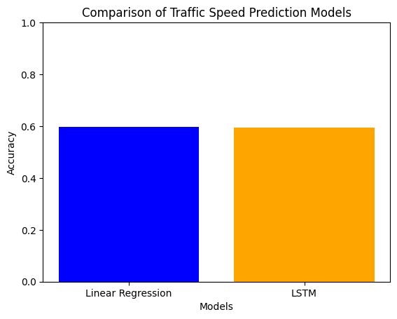

Main title: Deep Learning Based Traffic Speed Prediction Using Long Short Term Memory for Improving Accuracy Compared with LSTM Algorithm

CODE:

import pandas as pd

import numpy as np

from sklearn.model_selection import train_test_split

from sklearn.linear_model import LinearRegression

from sklearn.metrics import mean_squared_error

from sklearn.preprocessing import MinMaxScaler

from tensorflow.keras.models import Sequential

from tensorflow.keras.layers import LSTM, Dense

import matplotlib.pyplot as plt

# Load your dataset

file_path = 'your_dataset.csv' # Replace with the actual path to your dataset

df = pd.read_csv(file_path)

# Extract relevant features

features = df[['Year', 'Month', 'CarCount', 'BikeCount', 'BusCount', 'TruckCount', 'Total']]

target = df['Speed']

# Split the data into training and testing sets

X_train, X_test, y_train, y_test = train_test_split(features, target, test_size=0.2, random_state=42)

# Linear Regression Model

linear_model = LinearRegression()

linear_model.fit(X_train, y_train)

linear_predictions = linear_model.predict(X_test)

linear_rmse = np.sqrt(mean_squared_error(y_test, linear_predictions))

linear_accuracy = 1 - linear_rmse / np.mean(y_test)

print(f"Linear Regression Accuracy: {linear_accuracy * 100:.2f}%")

# LSTM Model

scaler = MinMaxScaler()

scaled_features = scaler.fit_transform(features)

X_lstm = np.array([scaled_features[i-6:i] for i in range(6, len(scaled_features))])

y_lstm = np.array(target[6:])

X_lstm_train, X_lstm_test, y_lstm_train, y_lstm_test = train_test_split(X_lstm, y_lstm, test_size=0.2, random_state=42)

lstm_model = Sequential()

lstm_model.add(LSTM(50, input_shape=(X_lstm_train.shape[1], X_lstm_train.shape[2])))

lstm_model.add(Dense(1))

lstm_model.compile(optimizer='adam', loss='mse')

lstm_model.fit(X_lstm_train, y_lstm_train, epochs=10, batch_size=32, verbose=1)

lstm_predictions = lstm_model.predict(X_lstm_test)

lstm_rmse = np.sqrt(mean_squared_error(y_lstm_test, lstm_predictions))

lstm_accuracy = 1 - lstm_rmse / np.mean(y_lstm_test)

print(f"LSTM Accuracy: {lstm_accuracy * 100:.2f}%")

# Plotting the comparison

labels = ['Linear Regression', 'LSTM']

accuracies = [linear_accuracy * 100, lstm_accuracy * 100]

plt.bar(labels, accuracies, color=['blue', 'orange'])

plt.ylabel('Accuracy (%)')

plt.title('Traffic Speed Prediction Accuracy Comparison')

plt.show()

